**CARBON FOOTPRINT CALCULATOR**

### A MINI PROJECT REPORT

#### Submitted by

**ALI AZAM KAZMI**

**[RA2011003010094]**

*Under the guidance of*

**Dr.T.K. SIVAKUMAR**

(Assistant Professor, C.TECH)

***In partial satisfaction of the requirements for the degree of***

### BACHELOR OF TECHNOLOGY

in

**COMPUTER SCIENCE & ENGINEERING**



**SCHOOL OF COMPUTING**

**COLLEGE OF ENGINEERING AND TECHNOLOGY**

**SRM INSTITUTE OF SCIENCE AND TECHNOLOGY**

**KATTANKULATHUR - 603203**

**MAY 2023**

|  |  |
| --- | --- |
|  | COLLEGE OF ENGINEERING & TECHNOLOGY  SRM INSTITUTE OF SCIENCE & TECHNOLOGY  S.R.M. NAGAR, KATTANKULATHUR – 603 203 |

**BONAFIDE CERTIFICATE**

Certified that this project report **“ Carbon Footprint Calculator”** is the bonafide work of **“ ALI AZAM KAZMI [RA2011003010094] ”** of III Year/VI Sem B.tech(CSE)who carried out the mini project work under my supervision for the course 18CSC303J- Database Management systems in SRM Institute of Science and Technology during the academic year 2022-2023(Even sem).

###### SIGNATURE

Dr.T.K SIVAKUMAR

ASSISTANT PROFESSOR

C.TECH

# ABSTRACT

A carbon calculator, as the name suggests, that calculates an individual's or business's carbon footprint. More often than not, these are estimates, not exact figures, but they can provide a baseline for where a company stands on sustainability. Carbon footprints are different from a country’s reported per capita emissions (for example, those reported under the United Nations Framework Convention on Climate Change). Rather than the greenhouse gas emissions associated with production, carbon footprints focus on the greenhouse gas emissions associated with consumption.. They include the emissions associated with goods that are imported into a country but are produced elsewhere and generally take into account emissions associated with international transport and shipping, which is not accounted for in standard national inventories. As a result, a country’s carbon footprint can increase even as carbon emissions within its borders decrease. Carbon footprints are different from a country’s reported per capita emissions. Rather than the greenhouse gas emissions associated with production, carbon footprints focus on the greenhouse gas emissions associated with consumption. High carbon footprint causes many problems such as climate change, toxic rain, adds to coastal and ocean acidification, and it also leads to melting of glaciers and polar ice.

iii

**TABLE OF CONTENTS**

**Chapter No. Title Page No.**

ABSTRACT iii

LIST OF ABBREVIATION iv

|  |  |  |  |
| --- | --- | --- | --- |
|  | **1 INTRODUCTION** | | **6** |
| 1.1 Introduction | | 6 |
| 1.2 Problem statement | | 7 |
| 1.3 Objectives  1.4 Scope and applications  1.5 Software Requirements Specification | | 8  9  11 |
| **2 SYSTEM ARCHITECTURE AND DESIGN** | | **14** |
| 2.1 Architecture Diagram | | 14 |
| 2.1.1 Front end (UI)design | | 15 |
| 2.1.2 Back end (Database) design | | 17 |
| 2.2 ER Diagram and Use case Diagram | | 18 |
| **3** | **CODING AND TESTING** | | **20** |
| **4** | **RESULTS AND DISCUSSIONS** | | **31** |
| **5** | | **CONCLUSION AND FUTURE ENHANCEMENT** | **34** |
| **6** | | **REFERENCES** | **35** |
|  | |  |  |
|  | |  |  |
|  | |  |  |
|  | |  |

# ABBREVIATIONS

**AES** Advanced Encryption Standard

**ANN** Artificial Neural Network

**CSS** Cascading Style Sheet

**CV** Computer Vision

**DB** Data Base

**DNA** Deoxyribo Neucleic Acid

**SQL** Structured Query Language

**SVM** Support Vector Machine

**UI** User Interface

I

**1.1 INTRODUCTION**

A carbon footprint (or greenhouse gas footprint) is a "certain amount of gaseous emissions that are relevant to climate change and associated with human production or consumption activities".[2] In some cases, the carbon footprint is expressed as the carbon dioxide equivalent (CO2e) which is meant to sum up the total greenhouse gas (GHG) emissions caused by an individual, event, organization, service, place or product.[3] In other cases, only the carbon dioxide emissions are taken into account but not those of other greenhouse gases.[4] Greenhouse gases, including the carbon-containing gases carbon dioxide and methane, can be emitted through the burning of fossil fuels, land clearance, and the production and consumption of food, manufactured goods, materials, wood, roads, buildings, transportation and other services.[5] Beyond calculating carbon footprints for whole countries, it is possible to calculate the footprint of cities and smaller regions like neighborhoods but even sectors, companies and products.[6][7]

The IPCC uses the following definition for carbon footprint: "Measure of the exclusive total amount of emissions of carbon dioxide (CO2 ) that is directly and indirectly caused by an activity or is accumulated over the lifecycle stages of a product."[4] They chose to adopt the same definition that had been proposed in 2007 by two scientists from the UK.[2] Those scientists had pointed out that there was no clear definition of the term yet.[2]

In this definition, only carbon dioxide is included in the analysis, rather than the carbon dioxide equivalents which would factor in other greenhouse gases as well. Their reasoning for not included other greenhouse gases was that those are more difficult to quantify. An inclusion of all greenhouse gases would also make the carbon footprint indicator less practical.[2]

Some organizations use the term greenhouse gas footprint or climate footprint[13] when all greenhouse gases are included via their global warming potential (or carbon dioxide equivalents).[citation needed] However, it is also common to understand carbon footprint in the same way, i.e. for all the greenhouse gases, not just for carbon dioxide.

**1.2 PROBLEM STATEMENTS**

Our carbon footprint has a negative impact on the environment in multiple ways: It is the main cause of human-induced climate change, it contributes to urban air pollution, it leads to toxic acid rain, it adds to coastal and ocean acidification, and it worsens the melting of glaciers and polar ice. Carbon footprints are different from a country’s reported per capita emissions (for example, those reported under the United Nations Framework Convention on Climate Change). Rather than the greenhouse gas emissions associated with production, carbon footprints focus on the greenhouse gas emissions associated with consumption.. They include the emissions associated with goods that are imported into a country but are produced elsewhere and generally take into account emissions associated with international transport and shipping, which is not accounted for in standard national inventories. As a result, a country’s carbon footprint can increase even as carbon emissions within its borders decrease.

**1.3 OBJECTIVES**

Carbon footprints estimate the total amount of greenhouse gasses emitted during the production, processing and retailing of consumer goods. The aim is to identify major sources of emissions in supply chains to inform relevant stakeholders so that actions can be taken to reduce emissions.

Identification of major sources of emission of carbon footprints, analysis of that data to perform predictions which enables us to take preventive measures against increasing carbon footprint levels in the future. This calculator is for anyone using electricity, who wants to know how much carbon footprint they produce, and eliminate it (by presenting the output equivalent to trees planted). This is called offsetting the carbon footprint. Of course, electricity is just a fraction of our total carbon footprint. But if you consume a lot of it, you might want to do something.

**1.4 SCOPE AND ITS APPLICATION**

The most important thing is to know where your electricity comes from. Unless you have 100% self-sufficient source of electricity, or you have exact data from your electricity provider, you don't know where exactly it is from.

We provide list of countries and their energy source percentages. But, some countries are very big, and the national average may not be even close to where your electricity comes from (source at the end of this document). Also, countries can buy and sell electricity from other countries.

We also provide median values for how much CO2 each power plant type produces. Again, they are just median (most "common") values (source at the end of this document) for each power plant type. This may differ based on exact model, age, or system used in each particular power plant.

Apart from that, calculations are straight forward and precise.

https://trees.org is the site to go, if you ask me. But that is up to you. Be responsible for your footprint on the planet!

How often to donate you ask? It takes few years for the tree to grow up to full potential, but then it "works" for you for around 40 years. This is continuous, so while you consume the same amount of energy every year, the tree manages to take care of that same amount - as calculated.

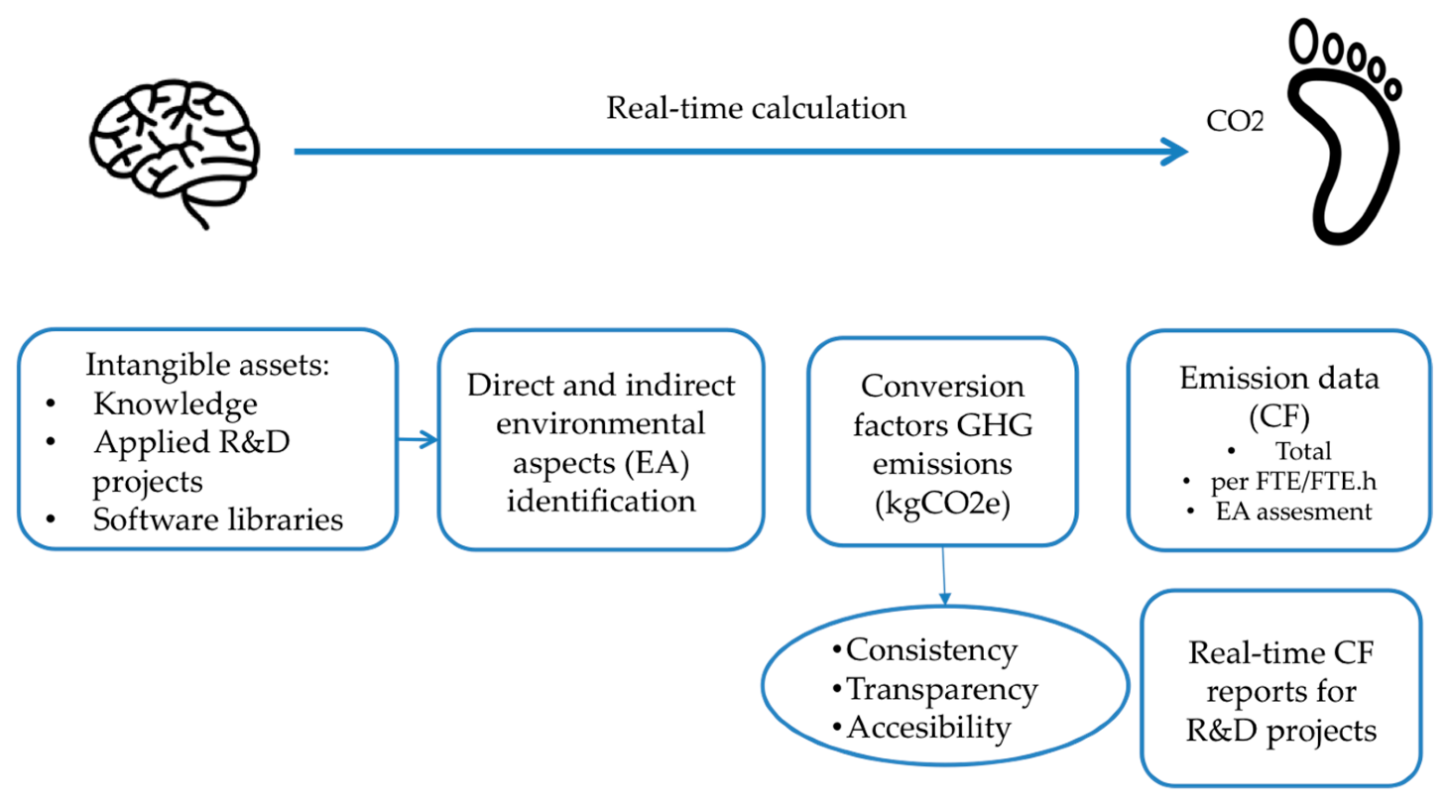

**Fig 1.1 Real Time calculation**

**1.5 SOFTWARE AND REQUIREMENTS**

We can proudly say that this calculator does not need any dependencies. It is pure HTML, CSS and JavaScript. Just open the html file in any modern web browser (note: not tested, [and won't be] in IE), and you are good to go!

HTML- deployment

Css-Styling the web page

Javascript- to calculate the Carbon footprint

Database of electricity

Create slideshows using HTML and Markdown and view them in a single HTML page.

You write all your slides in one html file. Each slide is written in its own <script> tag and you can use html, markdown and show programming code with syntax higlighted.

Here is how a markdown slide can be created, as part of a web page.

**1.6 HOW DOES IT WORKS**

As stated earlier, the carbon footprint is calculated by the tons of carbon dioxide individuals and companies produce annually.

Calculating carbon footprint revolves around evaluating everyday activities against their effects on the environment. For instance, if you cycled or walked to work, you leave a lesser carbon footprint as compared to a person who drove.

Also, as a farmer, you leave a significant carbon footprint. The reason being, farming is notorious for producing methane, a greenhouse gas that is harmful to the environment.

Manually calculating carbon footprint is difficult and tiresome. For this reason, you need a carbon footprint calculator.

A carbon footprint calculator offers a more accurate and convenient way to calculate the amount of carbon dioxide in our environment, helping us make better decisions when trying to offset the existing carbon footprint.

Below is a breakdown of the average carbon footprint from daily activities.

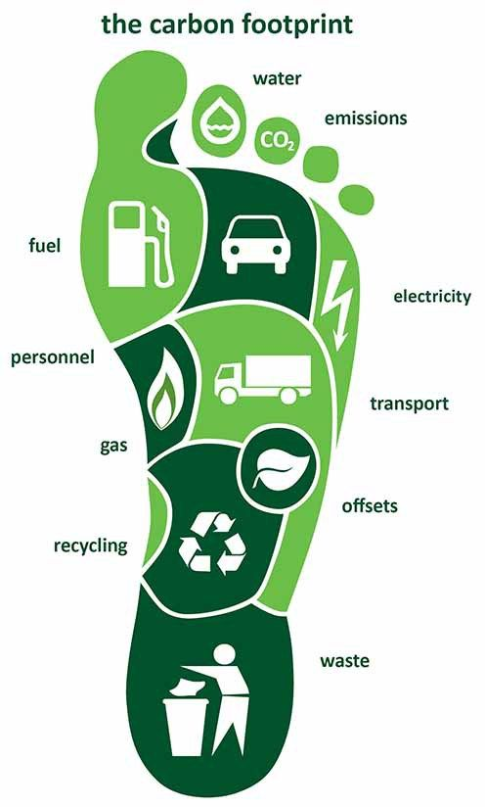

**Fig 1.2 Carbon Footprint**

**2. SYSTEM ARCHITECTURE AND DIAGRAM**

**2.1 ARCHITECTURE DIAGRAM**

The architecture diagram for a carbon footprint calculator typically includes several components that work together to provide accurate calculations of carbon emissions. Here is an overview of the key components and their functions: (fig 2.1)

User interface: This is the front-end component that allows users to interact with the carbon footprint calculator. The user interface typically includes a web or mobile application where users can input data such as their energy usage, transportation habits, and diet.(fig 2.2)

Database: The database is where all the input data from the user interface is stored. This data is used to calculate the user's carbon footprint.fig(2.3)

Carbon footprint calculator algorithm: This is the heart of the carbon footprint calculator. It uses the data from the database to calculate the user's carbon emissions. The algorithm may take into account factors such as the user's energy usage, transportation habits, food consumption, and other lifestyle factors.

Emission factors database: The emission factors database is a reference database that contains information on the carbon emissions associated with different activities. For example, it may contain data on the carbon emissions associated with driving a car or eating a hamburger.

Calculation engine: The calculation engine takes the data from the database and the emission factors database and applies the carbon footprint calculator algorithm to calculate the user's carbon emissions.

Reporting and visualization: Once the carbon emissions have been calculated, the reporting and visualization component displays the results to the user in an easy-to-understand format. This may include charts, graphs, and other visualizations that show the user's carbon footprint broken down by different categories such as energy, transportation, and food.

Overall, the architecture diagram for a carbon footprint calculator is designed to be intuitive and user-friendly while also providing accurate and comprehensive calculations of carbon emissions.

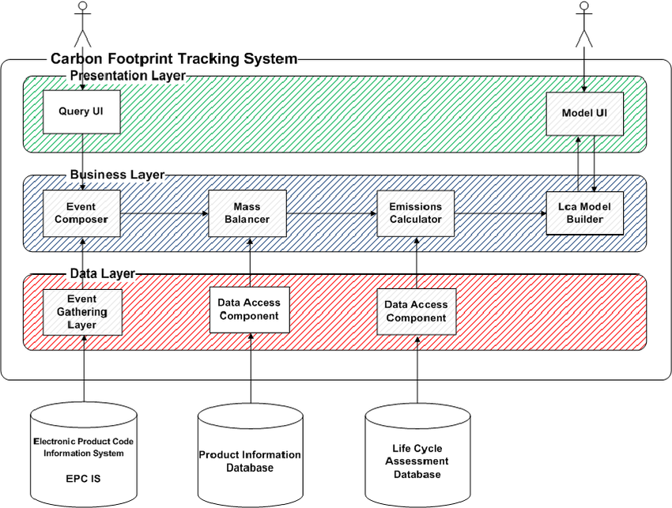

**Fig 2.1 Architecture Diagram**

**2.1.1 USER INTERFACE LAYER**

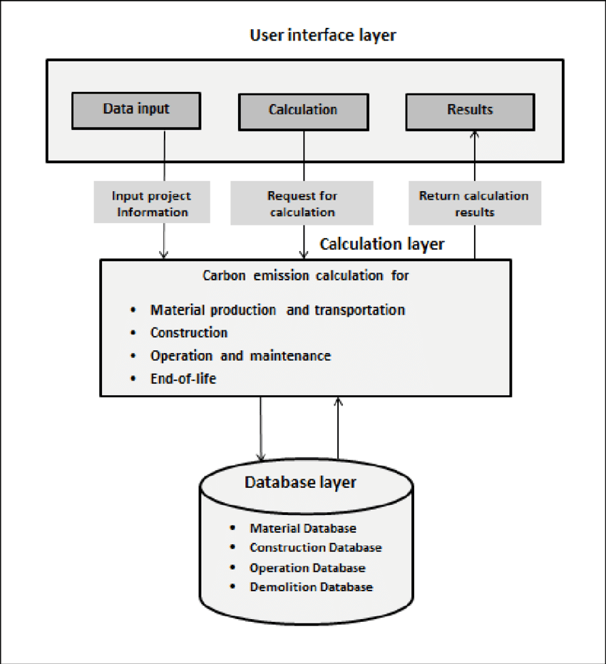

**Fig. 2.2 UI Layer**

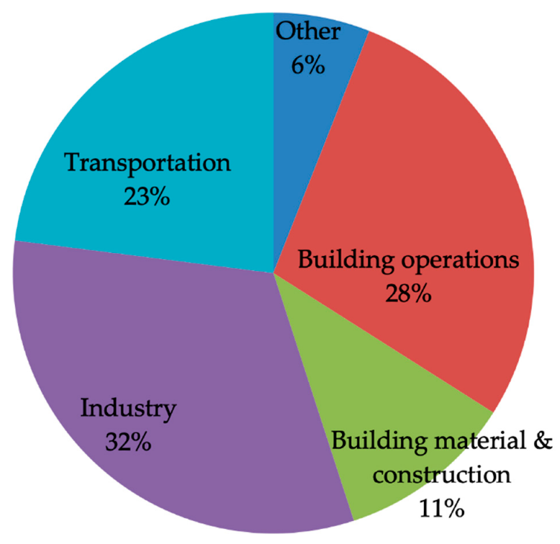

**Fig 2.3 Carbon distribution**

**2.1.2 USER INTERFACE LAYER**

**(Backend)**

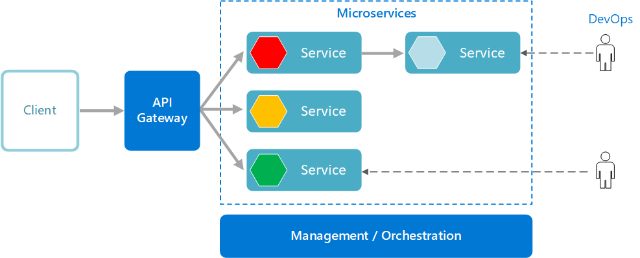

**Fig 2.4 Backend Layer**

**2.2 ER & USER CASE DIAGRAM**

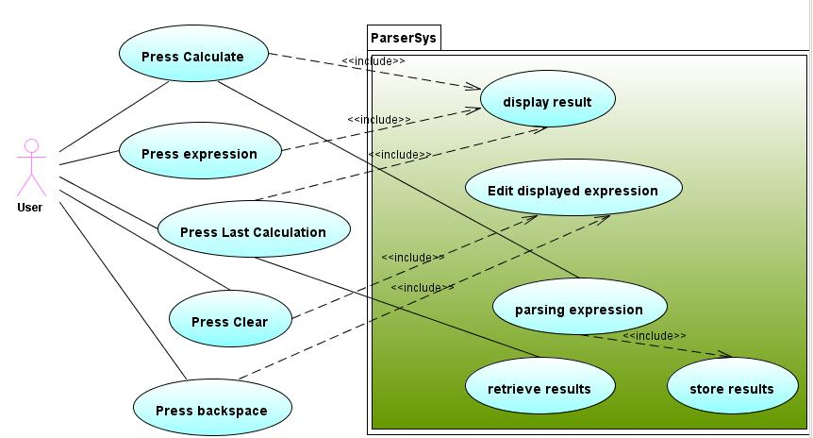

**Fig 2.5**

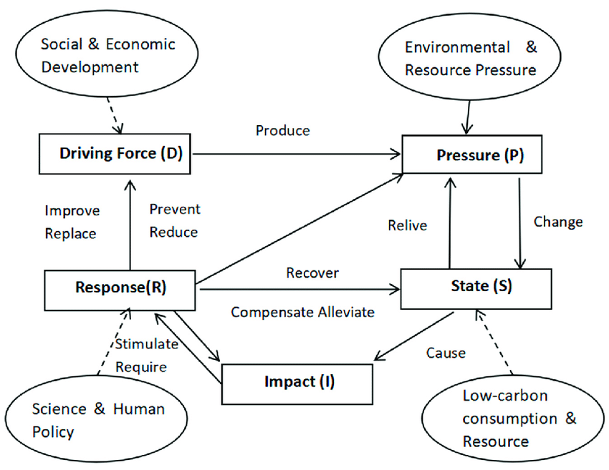

**Fig 2.6**

**3. CODING**

**FOR CALCULATION JAVASCRIPT**

const byId = id => document.getElementById(id);

csvData = CSVParse();

CountrySelected();

Calculate();

function CountrySelected() {

const country = byId("countries").value;

byId("coal%").value = (csvData[country]).Coal;

byId("gas%").value = (csvData[country]).Gas;

byId("oil%").value = (csvData[country]).Oil;

byId("hydro%").value = (csvData[country]).Hydro;

byId("renew%").value = (csvData[country]).Renewable;

byId("nuclear%").value = (csvData[country]).Nuclear;

Calculate();

}

function Calculate() {

const e = byId("powerUnit");

const power = byId("power").value / e.options[e.selectedIndex].value;

const totalPercentage = Number(byId("coal%").value) + Number(byId("gas%").value) + Number(byId("oil%").value) + Number(byId("hydro%").value) + Number(byId("renew%").value) + Number(byId("nuclear%").value) + Number(byId("custom%").value);

byId("total%").textContent = Math.round(totalPercentage * 10) / 10 + "%";

const kgCO2result = ((byId("coal%").value * byId("coalCO").value + byId("gas%").value * byId("gasCO").value + byId("oil%").value * byId("oilCO").value +

byId("hydro%").value * byId("hydroCO").value + byId("renew%").value * byId("renewCO").value + byId("nuclear%").value * byId("nuclearCO").value +

byId("custom%").value * byId("customCO").value) / 100000) * 24 * 365.2422 * power; //Yes, I am accounting for the leap year. Yes, I am a nerd.

const treesRequired = kgCO2result / 15.7;

byId("kgCO2result").textContent = ((Math.ceil(kgCO2result)).toLocaleString('en')).replace(/,/g, " ");

byId("treesRequired").textContent = ((Math.ceil(treesRequired)).toLocaleString('en')).replace(/,/g, " ");

byId("priceRequired").textContent = ((Math.round(treesRequired / 10)).toLocaleString('en')).replace(/,/g, " ");

}

function CSVParse() {

//CSV->JSON from /Sources/data.csv

const rawData = `{"Albania":{"Coal":0,"Gas":0,"Oil":0,"Hydro":100,"Renewable":0,"Nuclear":0},"Algeria":{"Coal":0,"Gas":97.8,"Oil":1.8,"Hydro":0.4,"Renewable":0,"Nuclear":0},"Angola":{"Coal":0,"Gas":0,"Oil":46.8,"Hydro":53.2,"Renewable":0,"Nuclear":0},"Argentina":{"Coal":2.9,"Gas":47.7,"Oil":13.8,"Hydro":29,"Renewable":2.5,"Nuclear":4.1},"Armenia":{"Coal":0,"Gas":42.4,"Oil":0,"Hydro":25.7,"Renewable":0.1,"Nuclear":31.8},"Australia":{"Coal":61.2,"Gas":21.9,"Oil":2,"Hydro":7.4,"Renewable":7.5,"Nuclear":0},"Austria":{"Coal":8,"Gas":8.8,"Oil":1,"Hydro":66.6,"Renewable":14.6,"Nuclear":0},"Azerbaijan":{"Coal":0,"Gas":93.9,"Oil":0.2,"Hydro":5.3,"Renewable":0.4,"Nuclear":0},"Bahrain":{"Coal":0,"Gas":100,"Oil":0,"Hydro":0,"Renewable":0,"Nuclear":0},"Bangladesh":{"Coal":2,"Gas":82,"Oil":14.7,"Hydro":1.1,"Renewable":0.3,"Nuclear":0},"Belarus":{"Coal":0.1,"Gas":98,"Oil":1.1,"Hydro":0.3,"Renewable":0.4,"Nuclear":0},"Belgium":{"Coal":6.2,"Gas":27,"Oil":0.3,"Hydro":0.4,"Renewable":16.6,"Nuclear":47.2},"Benin":{"Coal":0,"Gas":0,"Oil":99.5,"Hydro":0,"Renewable":0.5,"Nuclear":0},"Bolivia":{"Coal":0,"Gas":70,"Oil":2,"Hydro":25.7,"Renewable":2.3,"Nuclear":0},"Bosnia and Herzegovina":{"Coal":62.8,"Gas":0.2,"Oil":0.3,"Hydro":36.7,"Renewable":0,"Nuclear":0},"Botswana":{"Coal":95.8,"Gas":0,"Oil":4.2,"Hydro":0,"Renewable":0,"Nuclear":0},"Brazil":{"Coal":4.5,"Gas":13.7,"Oil":6,"Hydro":63.2,"Renewable":9.9,"Nuclear":2.6},"Brunei Darussalam":{"Coal":0,"Gas":99,"Oil":1,"Hydro":0,"Renewable":0,"Nuclear":0},"Bulgaria":{"Coal":45.4,"Gas":4.6,"Oil":0.4,"Hydro":9.8,"Renewable":5.9,"Nuclear":33.8},"Cambodia":{"Coal":28.2,"Gas":0,"Oil":10.7,"Hydro":60.5,"Renewable":0.6,"Nuclear":0},"Cameroon":{"Coal":0,"Gas":12.9,"Oil":12.8,"Hydro":73.2,"Renewable":1,"Nuclear":0},"Canada":{"Coal":9.9,"Gas":9.4,"Oil":1.2,"Hydro":58.3,"Renewable":4.5,"Nuclear":16.4},"Chile":{"Coal":35.3,"Gas":16.9,"Oil":6.2,"Hydro":31.3,"Renewable":9.8,"Nuclear":0},"China":{"Coal":72.6,"Gas":2,"Oil":0.2,"Hydro":18.6,"Renewable":4.1,"Nuclear":2.3},"Hong Kong SAR, China":{"Coal":76.2,"Gas":23,"Oil":0.6,"Hydro":0,"Renewable":0.2,"Nuclear":0},"Colombia":{"Coal":10.2,"Gas":15.3,"Oil":0.2,"Hydro":71.1,"Renewable":3.1,"Nuclear":0},"Congo, Dem. Rep.":{"Coal":0,"Gas":0.1,"Oil":0,"Hydro":99.9,"Renewable":0,"Nuclear":0},"Congo, Rep.":{"Coal":0,"Gas":45.3,"Oil":0,"Hydro":54.7,"Renewable":0,"Nuclear":0},"Costa Rica":{"Coal":0,"Gas":0,"Oil":10.2,"Hydro":65.7,"Renewable":24,"Nuclear":0},"Cote d'Ivoire":{"Coal":0,"Gas":69.9,"Oil":6.1,"Hydro":23.1,"Renewable":0.8,"Nuclear":0},"Croatia":{"Coal":17.6,"Gas":7.5,"Oil":1,"Hydro":67,"Renewable":6.9,"Nuclear":0},"Cuba":{"Coal":0,"Gas":14.4,"Oil":81.6,"Hydro":0.5,"Renewable":3.5,"Nuclear":0},"Curacao":{"Coal":0,"Gas":0,"Oil":96.4,"Hydro":0,"Renewable":3.6,"Nuclear":0},"Cyprus":{"Coal":0,"Gas":0,"Oil":92.7,"Hydro":0,"Renewable":7.3,"Nuclear":0},"Czech Republic":{"Coal":51.5,"Gas":1.9,"Oil":0,"Hydro":2.2,"Renewable":8.5,"Nuclear":35.7},"Denmark":{"Coal":34.4,"Gas":6.5,"Oil":1,"Hydro":0,"Renewable":55.8,"Nuclear":0},"Dominican Republic":{"Coal":13.3,"Gas":21.5,"Oil":51.9,"Hydro":8.5,"Renewable":4.7,"Nuclear":0},"Ecuador":{"Coal":0,"Gas":13.3,"Oil":37.5,"Hydro":47.1,"Renewable":2,"Nuclear":0},"Egypt, Arab Rep.":{"Coal":0,"Gas":78.7,"Oil":12.2,"Hydro":8.1,"Renewable":0.9,"Nuclear":0},"El Salvador":{"Coal":0,"Gas":0,"Oil":40.3,"Hydro":27.6,"Renewable":32.1,"Nuclear":0},"Eritrea":{"Coal":0,"Gas":0,"Oil":99.5,"Hydro":0,"Renewable":0.5,"Nuclear":0},"Estonia":{"Coal":87.4,"Gas":0.6,"Oil":0.3,"Hydro":0.2,"Renewable":10.9,"Nuclear":0},"Ethiopia":{"Coal":0,"Gas":0,"Oil":0.1,"Hydro":95.6,"Renewable":4.3,"Nuclear":0},"Finland":{"Coal":17.4,"Gas":8.1,"Oil":0.3,"Hydro":19.7,"Renewable":18.9,"Nuclear":34.6},"France":{"Coal":2.2,"Gas":2.3,"Oil":0.3,"Hydro":11.3,"Renewable":5.1,"Nuclear":78.4},"Gabon":{"Coal":0,"Gas":38.9,"Oil":27,"Hydro":33.6,"Renewable":0.5,"Nuclear":0},"Georgia":{"Coal":0,"Gas":19.6,"Oil":0,"Hydro":80.4,"Renewable":0,"Nuclear":0},"Germany":{"Coal":45.8,"Gas":10,"Oil":0.9,"Hydro":3.1,"Renewable":23,"Nuclear":15.6},"Ghana":{"Coal":0,"Gas":18.2,"Oil":17.1,"Hydro":64.7,"Renewable":0,"Nuclear":0},"Greece":{"Coal":51.1,"Gas":13.5,"Oil":11,"Hydro":8.9,"Renewable":15.3,"Nuclear":0},"Guatemala":{"Coal":17.3,"Gas":0,"Oil":14.1,"Hydro":45.2,"Renewable":23.4,"Nuclear":0},"Haiti":{"Coal":0,"Gas":0,"Oil":91.3,"Hydro":8.7,"Renewable":0,"Nuclear":0},"Honduras":{"Coal":0.5,"Gas":0,"Oil":55.7,"Hydro":32.4,"Renewable":11.5,"Nuclear":0},"Hungary":{"Coal":20.8,"Gas":14.4,"Oil":0.2,"Hydro":1,"Renewable":9.7,"Nuclear":53.3},"Iceland":{"Coal":0,"Gas":0,"Oil":0,"Hydro":71,"Renewable":28.9,"Nuclear":0},"India":{"Coal":75.1,"Gas":4.9,"Oil":1.8,"Hydro":10.2,"Renewable":5.2,"Nuclear":2.8},"Indonesia":{"Coal":52.6,"Gas":24.6,"Oil":11.3,"Hydro":6.6,"Renewable":4.8,"Nuclear":0},"Iran, Islamic Rep.":{"Coal":0.2,"Gas":71.3,"Oil":21.7,"Hydro":5,"Renewable":0.1,"Nuclear":1.6},"Iraq":{"Coal":0,"Gas":21.9,"Oil":73.7,"Hydro":4.3,"Renewable":0,"Nuclear":0},"Ireland":{"Coal":24.9,"Gas":49.6,"Oil":0.7,"Hydro":2.7,"Renewable":21.8,"Nuclear":0},"Israel":{"Coal":49.6,"Gas":48.4,"Oil":0.5,"Hydro":0,"Renewable":1.5,"Nuclear":0},"Italy":{"Coal":16.7,"Gas":33.7,"Oil":5.1,"Hydro":21.1,"Renewable":22.3,"Nuclear":0},"Jamaica":{"Coal":0,"Gas":0,"Oil":90.2,"Hydro":3.3,"Renewable":6.5,"Nuclear":0},"Japan":{"Coal":33.7,"Gas":40.6,"Oil":11.2,"Hydro":7.9,"Renewable":6.1,"Nuclear":0},"Jordan":{"Coal":0,"Gas":7.1,"Oil":92.5,"Hydro":0.3,"Renewable":0,"Nuclear":0},"Kazakhstan":{"Coal":71.9,"Gas":19.2,"Oil":1,"Hydro":7.9,"Renewable":0,"Nuclear":0},"Kenya":{"Coal":0,"Gas":0,"Oil":18.5,"Hydro":35.8,"Renewable":45.7,"Nuclear":0},"Korea, Dem. People’s Rep.":{"Coal":24.1,"Gas":0,"Oil":3.3,"Hydro":72.6,"Renewable":0,"Nuclear":0},"Korea, Rep.":{"Coal":42.4,"Gas":23.9,"Oil":3.2,"Hydro":0.5,"Renewable":1.1,"Nuclear":28.7},"Kosovo":{"Coal":96.9,"Gas":0,"Oil":0.3,"Hydro":2.8,"Renewable":0,"Nuclear":0},"Kuwait":{"Coal":0,"Gas":33.7,"Oil":66.3,"Hydro":0,"Renewable":0,"Nuclear":0},"Kyrgyz Republic":{"Coal":7.4,"Gas":0.8,"Oil":0.6,"Hydro":91.3,"Renewable":0,"Nuclear":0},"Latvia":{"Coal":0,"Gas":45.5,"Oil":0,"Hydro":38.8,"Renewable":15.8,"Nuclear":0},"Lebanon":{"Coal":0,"Gas":0,"Oil":98.9,"Hydro":1.1,"Renewable":0,"Nuclear":0},"Libya":{"Coal":0,"Gas":53.7,"Oil":46.3,"Hydro":0,"Renewable":0,"Nuclear":0},"Lithuania":{"Coal":0.1,"Gas":47.2,"Oil":4.3,"Hydro":10.8,"Renewable":30,"Nuclear":0},"Luxembourg":{"Coal":0,"Gas":76.2,"Oil":0,"Hydro":5.7,"Renewable":15.3,"Nuclear":0},"Macedonia, FYR":{"Coal":69.5,"Gas":3.6,"Oil":2.8,"Hydro":22.5,"Renewable":1.6,"Nuclear":0},"Malaysia":{"Coal":37.9,"Gas":50.1,"Oil":2.4,"Hydro":9.1,"Renewable":0.6,"Nuclear":0},"Malta":{"Coal":0,"Gas":0,"Oil":96.7,"Hydro":0,"Renewable":3.3,"Nuclear":0},"Mauritius":{"Coal":42.9,"Gas":0,"Oil":36.7,"Hydro":3.1,"Renewable":17.2,"Nuclear":0},"Mexico":{"Coal":11.2,"Gas":57,"Oil":10.9,"Hydro":12.9,"Renewable":4.6,"Nuclear":3.2},"Moldova":{"Coal":0,"Gas":93.5,"Oil":0.3,"Hydro":5.9,"Renewable":0.3,"Nuclear":0},"Mongolia":{"Coal":92.3,"Gas":0,"Oil":4.5,"Hydro":0,"Renewable":3.2,"Nuclear":0},"Montenegro":{"Coal":44.8,"Gas":0,"Oil":0,"Hydro":55.2,"Renewable":0,"Nuclear":0},"Morocco":{"Coal":55,"Gas":19.5,"Oil":13.1,"Hydro":5.7,"Renewable":6.7,"Nuclear":0},"Mozambique":{"Coal":0,"Gas":8.8,"Oil":0,"Hydro":91.2,"Renewable":0,"Nuclear":0},"Myanmar":{"Coal":2,"Gas":35.2,"Oil":0.5,"Hydro":62.4,"Renewable":0,"Nuclear":0},"Namibia":{"Coal":0,"Gas":0,"Oil":0.9,"Hydro":99.1,"Renewable":0,"Nuclear":0},"Nepal":{"Coal":0,"Gas":0,"Oil":0,"Hydro":99.8,"Renewable":0.2,"Nuclear":0},"Netherlands":{"Coal":31.3,"Gas":49.8,"Oil":1.8,"Hydro":0.1,"Renewable":11.2,"Nuclear":4},"New Zealand":{"Coal":4.5,"Gas":16.3,"Oil":0,"Hydro":55.9,"Renewable":23.2,"Nuclear":0},"Nicaragua":{"Coal":0,"Gas":0,"Oil":46.1,"Hydro":8.9,"Renewable":45,"Nuclear":0},"Niger":{"Coal":71.6,"Gas":0,"Oil":27.8,"Hydro":0,"Renewable":0.6,"Nuclear":0},"Nigeria":{"Coal":0,"Gas":82.4,"Oil":0,"Hydro":17.6,"Renewable":0,"Nuclear":0},"Norway":{"Coal":0.1,"Gas":1.8,"Oil":0,"Hydro":96,"Renewable":1.7,"Nuclear":0},"Oman":{"Coal":0,"Gas":97.4,"Oil":2.6,"Hydro":0,"Renewable":0,"Nuclear":0},"Pakistan":{"Coal":0.2,"Gas":25.1,"Oil":39.7,"Hydro":29.8,"Renewable":0.4,"Nuclear":4.8},"Panama":{"Coal":7.4,"Gas":0,"Oil":36.8,"Hydro":54.2,"Renewable":1.6,"Nuclear":0},"Paraguay":{"Coal":0,"Gas":0,"Oil":0,"Hydro":100,"Renewable":0,"Nuclear":0},"Peru":{"Coal":0.7,"Gas":45.9,"Oil":1.2,"Hydro":48.8,"Renewable":3.4,"Nuclear":0},"Philippines":{"Coal":42.8,"Gas":24.2,"Oil":7.4,"Hydro":11.8,"Renewable":13.8,"Nuclear":0},"Poland":{"Coal":83,"Gas":3.4,"Oil":1,"Hydro":1.4,"Renewable":11.1,"Nuclear":0},"Portugal":{"Coal":23,"Gas":13.2,"Oil":2.6,"Hydro":30,"Renewable":30.8,"Nuclear":0},"Qatar":{"Coal":0,"Gas":100,"Oil":0,"Hydro":0,"Renewable":0,"Nuclear":0},"Romania":{"Coal":27.3,"Gas":12.4,"Oil":0.7,"Hydro":28.8,"Renewable":12.8,"Nuclear":17.9},"Russian Federation":{"Coal":14.9,"Gas":50.2,"Oil":1,"Hydro":16.5,"Renewable":0.1,"Nuclear":17},"Saudi Arabia":{"Coal":0,"Gas":51.2,"Oil":48.8,"Hydro":0,"Renewable":0,"Nuclear":0},"Senegal":{"Coal":0,"Gas":4.2,"Oil":83.6,"Hydro":8.7,"Renewable":1.8,"Nuclear":0},"Serbia":{"Coal":66.3,"Gas":0.7,"Oil":0,"Hydro":32.9,"Renewable":0.1,"Nuclear":0},"Singapore":{"Coal":1.1,"Gas":95.3,"Oil":0.7,"Hydro":0,"Renewable":1.7,"Nuclear":0},"Slovak Republic":{"Coal":12.4,"Gas":6,"Oil":1.1,"Hydro":15.5,"Renewable":7.4,"Nuclear":57.1},"Slovenia":{"Coal":21.9,"Gas":2.2,"Oil":0.2,"Hydro":35.5,"Renewable":3,"Nuclear":37.1},"South Africa":{"Coal":93,"Gas":0,"Oil":0.1,"Hydro":0.4,"Renewable":1,"Nuclear":5.5},"South Sudan":{"Coal":0,"Gas":0,"Oil":99.6,"Hydro":0,"Renewable":0.4,"Nuclear":0},"Spain":{"Coal":16.5,"Gas":17.2,"Oil":5.1,"Hydro":14.2,"Renewable":25.9,"Nuclear":20.8},"Sri Lanka":{"Coal":25.7,"Gas":0,"Oil":35.1,"Hydro":36.5,"Renewable":2.7,"Nuclear":0},"Sudan":{"Coal":0,"Gas":0,"Oil":21.7,"Hydro":78.3,"Renewable":0,"Nuclear":0},"Suriname":{"Coal":0,"Gas":0,"Oil":37.7,"Hydro":62.3,"Renewable":0,"Nuclear":0},"Sweden":{"Coal":0.6,"Gas":0.3,"Oil":0.2,"Hydro":41.5,"Renewable":14.3,"Nuclear":42.3},"Switzerland":{"Coal":0,"Gas":0.7,"Oil":0.1,"Hydro":54.3,"Renewable":3.8,"Nuclear":39.3},"Syrian Arab Republic":{"Coal":0,"Gas":64.4,"Oil":21.8,"Hydro":13.8,"Renewable":0,"Nuclear":0},"Tajikistan":{"Coal":0,"Gas":2.9,"Oil":0,"Hydro":97.1,"Renewable":0,"Nuclear":0},"Tanzania":{"Coal":0,"Gas":42.2,"Oil":15.5,"Hydro":41.6,"Renewable":0.6,"Nuclear":0},"Thailand":{"Coal":21.6,"Gas":68.3,"Oil":1,"Hydro":3.2,"Renewable":5.9,"Nuclear":0},"Togo":{"Coal":0,"Gas":0,"Oil":12,"Hydro":84.5,"Renewable":3.5,"Nuclear":0},"Trinidad and Tobago":{"Coal":0,"Gas":99.8,"Oil":0.2,"Hydro":0,"Renewable":0,"Nuclear":0},"Tunisia":{"Coal":0,"Gas":94.2,"Oil":1.8,"Hydro":0.3,"Renewable":2.8,"Nuclear":0},"Turkey":{"Coal":30.3,"Gas":47.9,"Oil":0.9,"Hydro":16.1,"Renewable":4.8,"Nuclear":0},"Turkmenistan":{"Coal":0,"Gas":100,"Oil":0,"Hydro":0,"Renewable":0,"Nuclear":0},"Ukraine":{"Coal":38.7,"Gas":7,"Oil":0.1,"Hydro":4.7,"Renewable":0.9,"Nuclear":48.6},"United Arab":{"Coal":0,"Gas":98.4,"Oil":1.3,"Hydro":0,"Renewable":0.3,"Nuclear":0},"United Kingdom":{"Coal":30.4,"Gas":30,"Oil":0.5,"Hydro":1.8,"Renewable":17.7,"Nuclear":19},"United States":{"Coal":39.7,"Gas":26.9,"Oil":0.9,"Hydro":6.1,"Renewable":6.9,"Nuclear":19.2},"Uruguay":{"Coal":0,"Gas":0,"Oil":9.1,"Hydro":74.2,"Renewable":16.8,"Nuclear":0},"Uzbekistan":{"Coal":4.1,"Gas":74.2,"Oil":0.4,"Hydro":21.4,"Renewable":0,"Nuclear":0},"Venezuela, RB":{"Coal":0,"Gas":17.7,"Oil":14,"Hydro":68.3,"Renewable":0,"Nuclear":0},"Vietnam":{"Coal":24.5,"Gas":33.5,"Oil":0.3,"Hydro":41.5,"Renewable":0.1,"Nuclear":0},"Yemen, Rep.":{"Coal":0,"Gas":38.6,"Oil":61.4,"Hydro":0,"Renewable":0,"Nuclear":0},"Zambia":{"Coal":0,"Gas":0,"Oil":2.8,"Hydro":97.2,"Renewable":0,"Nuclear":0},"Zimbabwe":{"Coal":43.9,"Gas":0,"Oil":0.5,"Hydro":54.2,"Renewable":1.4,"Nuclear":0},"World":{"Coal":40.7,"Gas":21.6,"Oil":4.1,"Hydro":16.2,"Renewable":6,"Nuclear":10.6},"East Asia & Pacific":{"Coal":60.6,"Gas":13.5,"Oil":2.2,"Hydro":15,"Renewable":4.2,"Nuclear":3.8},"Europe & Central":{"Coal":24.1,"Gas":24.3,"Oil":1.3,"Hydro":16.6,"Renewable":10.5,"Nuclear":22.4},"Latin America & Caribbean":{"Coal":6.5,"Gas":26,"Oil":10.6,"Hydro":46.5,"Renewable":6.4,"Nuclear":1.9},"Middle East & North Afrika":{"Coal":3.4,"Gas":64.1,"Oil":28.8,"Hydro":2.6,"Renewable":0.4,"Nuclear":0.3},"North America":{"Coal":35.7,"Gas":24.6,"Oil":1,"Hydro":12.9,"Renewable":6.6,"Nuclear":18.9},"South Asia":{"Coal":65.7,"Gas":9.1,"Oil":5.2,"Hydro":11.6,"Renewable":4.6,"Nuclear":2.8},"Sub­Saharan Africa":{"Coal":51.4,"Gas":8.6,"Oil":4.3,"Hydro":21.2,"Renewable":1.7,"Nuclear":3}}`;

return JSON.parse(rawData);

}

**HTML & CSS**

<html lang="en">

<head>

    <link rel="stylesheet" href="style.css">

    <title>

        Carbon calculator

    </title>

</head>

<body>

    <form>

        <label for="countries">Preload the electricity generation stats by the country:</label>

        <select id="countries" onchange="CountrySelected()" autofocus>

        <option value="Albania">Albania</option>

        <option value="Algeria">Algeria</option>

        <option value="Angola">Angola</option>

        <option value="Argentina">Argentina</option>

        <option value="Armenia">Armenia</option>

        <option value="Australia">Australia</option>

        <option value="Austria">Austria</option>

        <option value="Azerbaijan">Azerbaijan</option>

        <option value="Bahrain">Bahrain</option>

        <option value="Bangladesh">Bangladesh</option>

        <option value="Belarus">Belarus</option>

        <option value="Belgium">Belgium</option>

        <option value="Benin">Benin</option>

        <option value="Bolivia">Bolivia</option>

        <option value="Bosnia and Herzegovina">Bosnia and Herzegovina</option>

        <option value="Botswana">Botswana</option>

        <option value="Brazil">Brazil</option>

        <option value="Brunei Darussalam">Brunei Darussalam</option>

        <option value="Bulgaria">Bulgaria</option>

        <option value="Cambodia">Cambodia</option>

        <option value="Cameroon">Cameroon</option>

        <option value="Canada">Canada</option>

        <option value="Chile">Chile</option>

        <option value="China">China</option>

        <option value="Hong Kong SAR, China">Hong Kong SAR, China</option>

        <option value="Colombia">Colombia</option>

        <option value="Congo, Dem. Rep.">Congo, Dem. Rep.</option>

        <option value="Congo, Rep.">Congo, Rep.</option>

        <option value="Costa Rica">Costa Rica</option>

        <option value="Cote d'Ivoire">Cote d'Ivoire</option>

        <option value="Croatia">Croatia</option>

        <option value="Cuba">Cuba</option>

        <option value="Curacao">Curacao</option>

        <option value="Cyprus">Cyprus</option>

        <option value="Czech Republic">Czech Republic</option>

        <option value="Denmark">Denmark</option>

        <option value="Dominican Republic">Dominican Republic</option>

        <option value="Ecuador">Ecuador</option>

        <option value="Egypt, Arab Rep.">Egypt, Arab Rep.</option>

        <option value="El Salvador">El Salvador</option>

        <option value="Eritrea">Eritrea</option>

        <option value="Estonia">Estonia</option>

        <option value="Ethiopia">Ethiopia</option>

        <option value="Finland">Finland</option>

        <option value="France">France</option>

        <option value="Gabon">Gabon</option>

        <option value="Georgia">Georgia</option>

        <option value="Germany">Germany</option>

        <option value="Ghana">Ghana</option>

        <option value="Greece">Greece</option>

        <option value="Guatemala">Guatemala</option>

        <option value="Haiti">Haiti</option>

        <option value="Honduras">Honduras</option>

        <option value="Hungary">Hungary</option>

        <option value="Iceland">Iceland</option>

        <option value="India">India</option>

        <option value="Indonesia">Indonesia</option>

        <option value="Iran, Islamic Rep.">Iran, Islamic Rep.</option>

        <option value="Iraq">Iraq</option>

        <option value="Ireland">Ireland</option>

        <option value="Israel">Israel</option>

        <option value="Italy">Italy</option>

        <option value="Jamaica">Jamaica</option>

        <option value="Japan">Japan</option>

        <option value="Jordan">Jordan</option>

        <option value="Kazakhstan">Kazakhstan</option>

        <option value="Kenya">Kenya</option>

        <option value="Korea, Dem. People’s Rep.">Korea, Dem. People’s Rep.</option>

        <option value="Korea, Rep.">Korea, Rep.</option>

        <option value="Kosovo">Kosovo</option>

        <option value="Kuwait">Kuwait</option>

        <option value="Kyrgyz Republic">Kyrgyz Republic</option>

        <option value="Latvia">Latvia</option>

        <option value="Lebanon">Lebanon</option>

        <option value="Libya">Libya</option>

        <option value="Lithuania">Lithuania</option>

        <option value="Luxembourg">Luxembourg</option>

        <option value="Macedonia, FYR">Macedonia, FYR</option>

        <option value="Malaysia">Malaysia</option>

        <option value="Malta">Malta</option>

        <option value="Mauritius">Mauritius</option>

        <option value="Mexico">Mexico</option>

        <option value="Moldova">Moldova</option>

        <option value="Mongolia">Mongolia</option>

        <option value="Montenegro">Montenegro</option>

        <option value="Morocco">Morocco</option>

        <option value="Mozambique">Mozambique</option>

        <option value="Myanmar">Myanmar</option>

        <option value="Namibia">Namibia</option>

        <option value="Nepal">Nepal</option>

        <option value="Netherlands">Netherlands</option>

        <option value="New Zealand">New Zealand</option>

        <option value="Nicaragua">Nicaragua</option>

        <option value="Niger">Niger</option>

        <option value="Nigeria">Nigeria</option>

        <option value="Norway">Norway</option>

        <option value="Oman">Oman</option>

        <option value="Pakistan">Pakistan</option>

        <option value="Panama">Panama</option>

        <option value="Paraguay">Paraguay</option>

        <option value="Peru">Peru</option>

        <option value="Philippines">Philippines</option>

        <option value="Poland">Poland</option>

        <option value="Portugal">Portugal</option>

        <option value="Qatar">Qatar</option>

        <option value="Romania">Romania</option>

        <option value="Russian Federation">Russian Federation</option>

        <option value="Saudi Arabia">Saudi Arabia</option>

        <option value="Senegal">Senegal</option>

        <option value="Serbia">Serbia</option>

        <option value="Singapore">Singapore</option>

        <option value="Slovak Republic">Slovak Republic</option>

        <option value="Slovenia">Slovenia</option>

        <option value="South Africa">South Africa</option>

        <option value="South Sudan">South Sudan</option>

        <option value="Spain">Spain</option>

        <option value="Sri Lanka">Sri Lanka</option>

        <option value="Sudan">Sudan</option>

        <option value="Suriname">Suriname</option>

        <option value="Sweden">Sweden</option>

        <option value="Switzerland">Switzerland</option>

        <option value="Syrian Arab Republic">Syrian Arab Republic</option>

        <option value="Tajikistan">Tajikistan</option>

        <option value="Tanzania">Tanzania</option>

        <option value="Thailand">Thailand</option>

        <option value="Togo">Togo</option>

        <option value="Trinidad and Tobago">Trinidad and Tobago</option>

        <option value="Tunisia">Tunisia</option>

        <option value="Turkey">Turkey</option>

        <option value="Turkmenistan">Turkmenistan</option>

        <option value="Ukraine">Ukraine</option>

        <option value="United Arab">United Arab</option>

        <option value="United Kingdom" selected>United Kingdom</option>

        <option value="United States">United States</option>

        <option value="Uruguay">Uruguay</option>

        <option value="Uzbekistan">Uzbekistan</option>

        <option value="Venezuela, RB">Venezuela, RB</option>

        <option value="Vietnam">Vietnam</option>

        <option value="Yemen, Rep.">Yemen, Rep.</option>

        <option value="Zambia">Zambia</option>

        <option value="Zimbabwe">Zimbabwe</option>

    </select>

        <br>

        <br>

        <table id="inputTable" class="inputTable">

            <tr>

                <td><label for="coal%">Coal</label></td>

                <td><input type="text" id="coal%" class="num" value="100" onkeyup="Calculate()"> %</td>

                <td><input type="text" id="coalCO" class="num" value="820" onkeyup="Calculate()"> gCO<sub>2</sub>/kWh</td>

            </tr>

            <tr>

                <td><label for="gas%">Natural gas</label></td>

                <td><input type="text" id="gas%" class="num" value="0" onkeyup="Calculate()"> %</td>

                <td><input type="text" id="gasCO" class="num" value="490" onkeyup="Calculate()"> gCO<sub>2</sub>/kWh</td>

            </tr>

            <tr>

                <td><label for="oil%">Oil</label></td>

                <td><input type="text" id="oil%" class="num" value="0" onkeyup="Calculate()"> %</td>

                <td><input type="text" id="oilCO" class="num" value="778" onkeyup="Calculate()"> gCO<sub>2</sub>/kWh</td>

            </tr>

            <tr>

                <td><label for="hydro%">Hydropower*</label></td>

                <td><input type="text" id="hydro%" class="num" value="0" onkeyup="Calculate()"> %</td>

                <td><input type="text" id="hydroCO" class="num" value="24" onkeyup="Calculate()"> gCO<sub>2</sub>/kWh</td>

            </tr>

            <tr>

                <td><label for="renew%">Renewable**</label></td>

                <td><input type="text" id="renew%" class="num" value="0" onkeyup="Calculate()"> %</td>

                <td><input type="text" id="renewCO" class="num" value="41" onkeyup="Calculate()"> gCO<sub>2</sub>/kWh</td>

            </tr>

            <tr>

                <td><label for="nuclear%">Nuclear</label></td>

                <td><input type="text" id="nuclear%" class="num" value="0" onkeyup="Calculate()"> %</td>

                <td><input type="text" id="nuclearCO" class="num" value="12" onkeyup="Calculate()"> gCO<sub>2</sub>/kWh</td>

            </tr>

            <tr>

                <td><label for="custom%">Custom</label></td>

                <td><input type="text" id="custom%" class="num" value="0" onkeyup="Calculate()"> %</td>

                <td><input type="text" id="customCO" class="num" value="0" onkeyup="Calculate()"> gCO<sub>2</sub>/kWh</td>

            </tr>

        </table>

        <br> Total percentage: <span id="total%"></span>

        <br>

        <label for="power">How much power do you use (continuously)?</label>

        <input type="text" id="power" value="1000" class="power" onkeyup="Calculate()">

        <select id="powerUnit" onchange="Calculate()">

        <option value="1000" id="W" selected>W</option>

        <option value="1" id="kW">kW</option>

        <option value="0.001" id="MW">MW</option>

        <option value="0.000001" id="GW">GW</option>

        <option value="0.000000001" id="TW">TW</option>

    </select>

        <br>

        <!--RESULTS-->

        You produce <b><span id="kgCO2result"></span></b> kg of CO<sub>2</sub> emissions per year.

        <br> You would need to plant <b><span id="treesRequired"></span></b> trees to eliminate your carbon footprint on our planet. pe="reset">

    </form>

    *gCO<sub>2</sub> can vary widely, read Wiki page in Sources

    <br> **using gCO2 values for Solar PV rooftop, read Wiki page in Sources for other values

    <br>

    <button title="Click to show/hide content" type="button" onclick="if(document.getElementById('spoiler').style.display==='none') {document.getElementById('spoiler').style.display=''}else{document.getElementById('spoiler').style.display='none'}">

    Sources and notes

</button>

    <div id="spoiler" style="display:none">

        <fieldset class="fieldSet">

            Electricity sources: <a href="http://wdi.worldbank.org/table/3.7">The World Bank statistics</a> (Data from 2015)

            <br> CO

            <sub>2</sub>/kWh values: Using median values from IPCC: Global warming potential of selected electricity sources (2014)

            <br> CO

            <sub>2</sub>/kWh values may differ a lot, especially when power plants use newest (better values), or older (worse values) technologies. Check the <a href="https://en.wikipedia.org/wiki/Life-cycle_greenhouse-gas_emissions_of_energy_sources">Wikipedia

        page</a> for Min/Max values.

            <br> This calculations assume that you use electricity proportionally from all power plants of your country.

            <br> If you know better where your electricity comes from (for example, you use your own solar power), edit the settings accordingly.

            <br> One tree can eliminate 15.7 kg of CO<sub>2</sub> per year. Source: <a href="https://www.tfaforms.com/4666774">https://www.tfaforms.com/4666774</a>

            <br>

        </fieldset>

    </div>

    <br> If you have questions or suggestions about this calculator, contact me at <i>github.com/aliazam1291</i>.

    <script src="co2calc.js"></script>

</body>

</html>

**4. RESULTS**

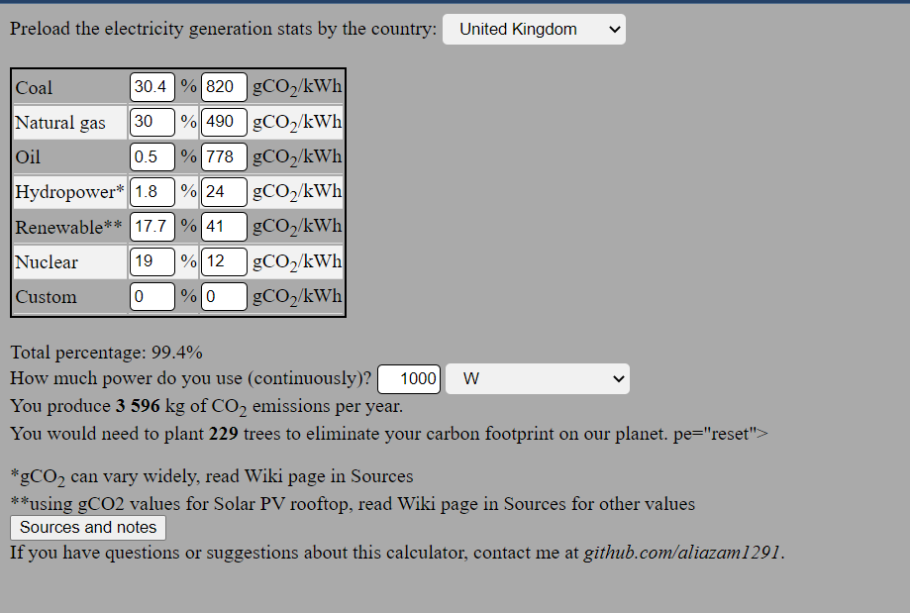

**Fig 4.1**

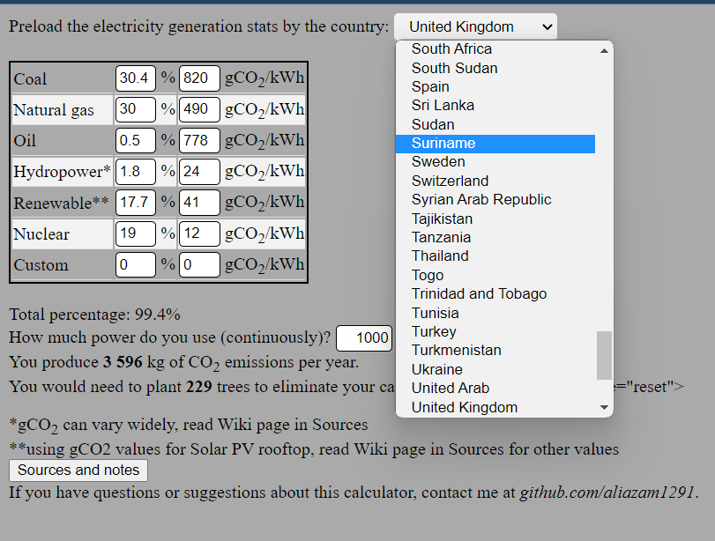

**Fig 4.2**

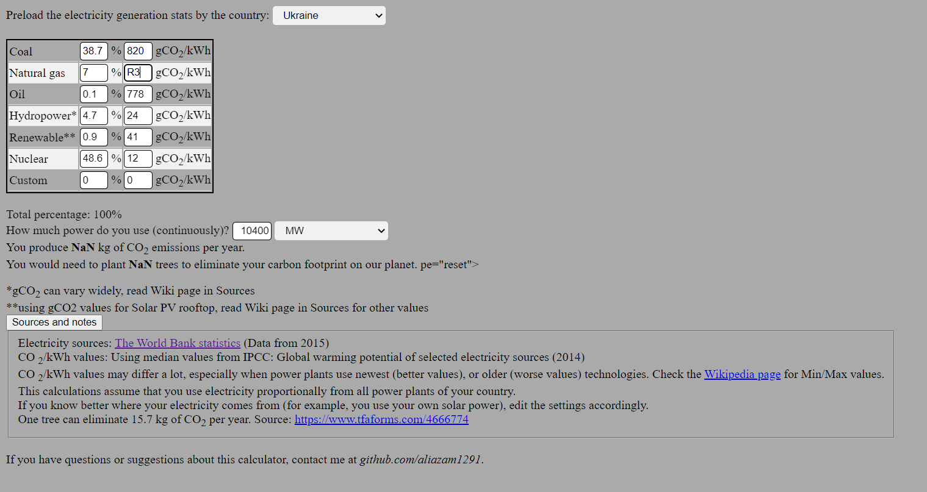

**Fig 4.3**

**5. CONCLUSION AND ENHANCEMENTS**

Include a wide range of emissions sources: Carbon emissions can come from a variety of sources, including transportation, energy use, food production, and waste management. A comprehensive calculator should take into account all of these sources to provide a more accurate estimate of an individual's carbon footprint.

Use the most up-to-date emissions factors: Emissions factors are used to calculate the amount of greenhouse gases emitted from a particular activity. It's important to use the most current and accurate emissions factors available to ensure the most accurate results.

Provide actionable recommendations: Once users have calculated their carbon footprint, it's important to provide them with actionable recommendations for reducing their emissions. This could include suggestions for changing behavior, such as driving less or eating a more plant-based diet, as well as information on purchasing carbon offsets or investing in renewable energy.

Make it user-friendly: Carbon emission calculators can be complex, so it's important to make them as user-friendly as possible. This could include using clear and concise language, providing helpful tips and guidance throughout the process, and using engaging visuals to help users understand their carbon footprint.

In conclusion, carbon emission calculators can be a powerful tool for raising awareness about the impact of individual behavior on the environment. By including a wide range of emissions sources, using up-to-date emissions factors, providing actionable recommendations, and making the calculator user-friendly, we can empower individuals to take action to reduce their carbon footprint and contribute to a more sustainable future.

**6. REFERENCES**

Energy sources by country

http://wdi.worldbank.org/table/3.7 (data from 2015)

You can see/use this information in /Sources folder processed into .xlsx and .csv formats

Amounts of CO2 produced per kWh based on power plant type

Original source: "2014 IPCC, Global warming potential of selected electricity sources"

Found at https://en.wikipedia.org/wiki/Life-cycle_greenhouse-gas_emissions_of_energy_sources - read more if you are interested, or want to use other (more optimistic or pessimistic) values for gCO2/kWh calculations

kG of CO2 eliminated per tree

According to https://www.tfaforms.com/4666774, it is roughly 15.7kg

International Journal of Low-Carbon Technologies, Volume 9, Issue 3, September 2014, Pages 237–243, https://doi.org/10.1093/ijlct/ctt041